Create Azure Blob Storage Container
- Login to Microsoft Azure Portal.

- Click Storage accounts.
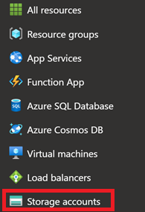
- Select Object storageBlob Storage.
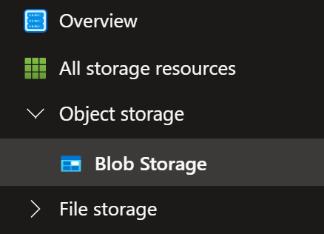
- Click Create button.


- Enter the following:
- Subscription
- Resource Group
- Storage Account Name
- Region
- Preferred Storage Type
- Performance
- Redundancy
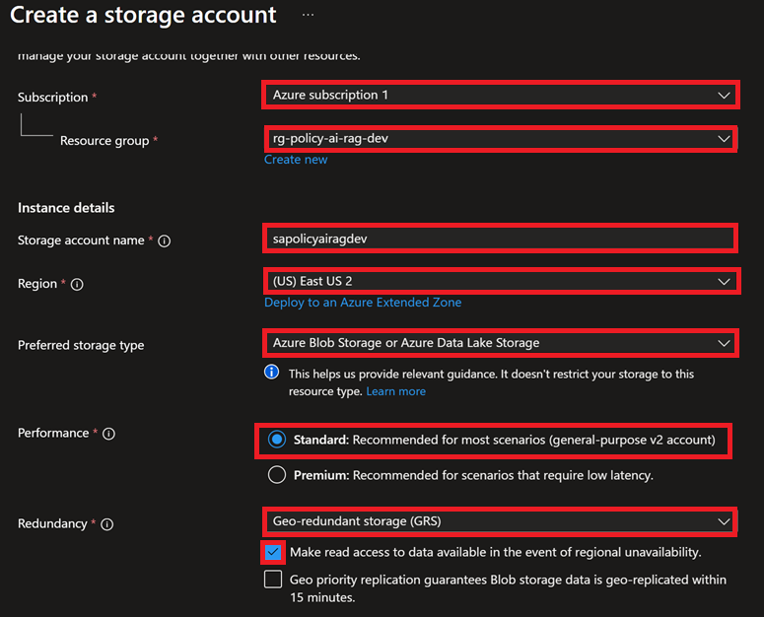
- Click Review + create button.

- Click Create button.


- Click Go to resource button to view storage account resource.
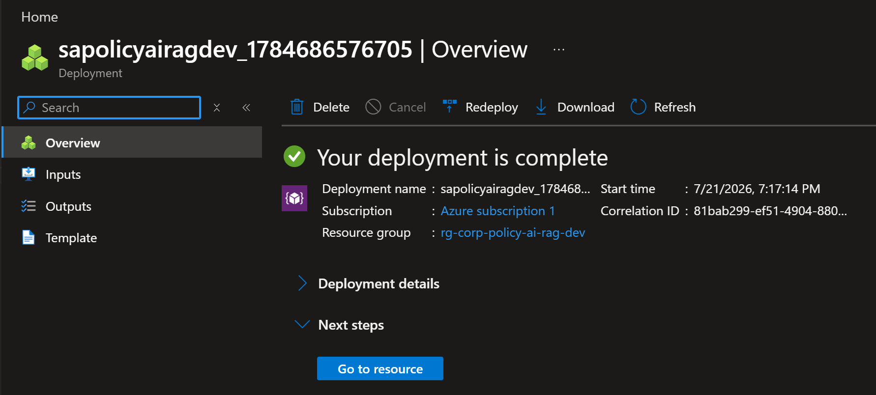
- Click Storage browser to create Blob Storage.
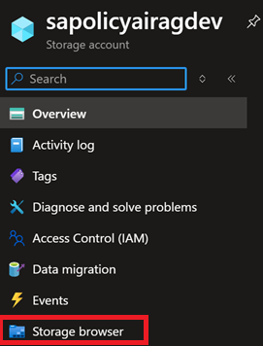
- Click Blob containers.
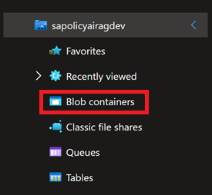

- Click Add container button.
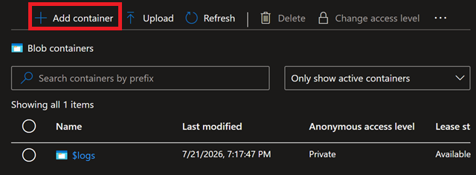
- Click Create button to create a new Blob storage container.
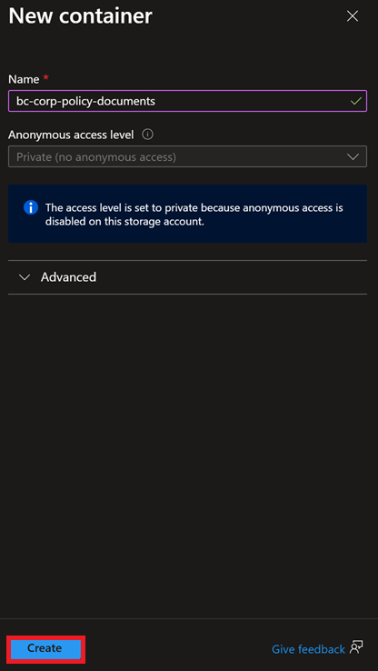
- Select Blob Storage Container radio button and click Upload button.
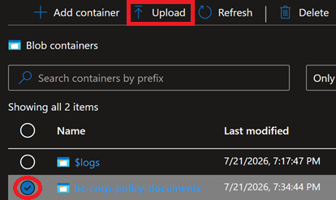

- Click Browse for files link to upload files to Blob Storage Container.
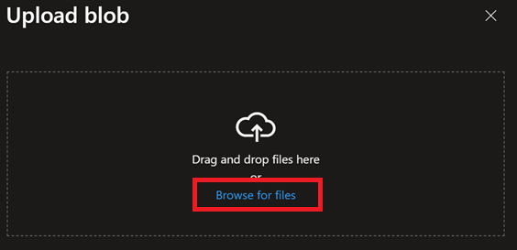
- Select Files to upload and click Open button.
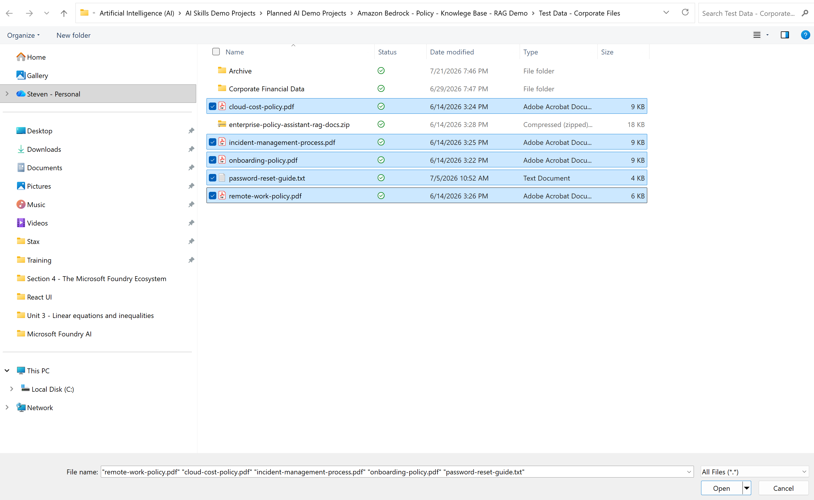
- Select Blob Storage Container, Overwrite if files already exist, and click Upload button.
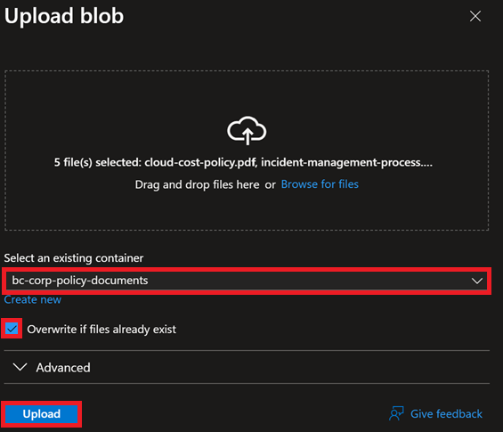

- Click Blob Storage Container link to go to Storage Container.
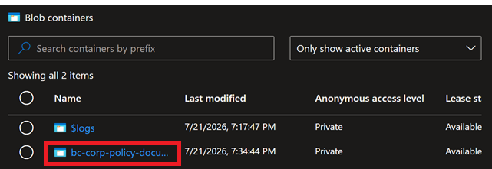
- See Uploaded Files in Blob Storage Container. Finished.
